# 

**Reaction Rates and Le Chatelier’s Principle**

Reaction rate: The rate at which reactants are consumed to create products ie. how fast successful collision occur.

~Collision theory; For a successful reaction to occur, reacting particles must:

1. Collide;
2. With sufficient energy ie. equal or exceed activation energy (Ea)
3. With the correct orientation

~Ways to increase reaction rate (increase total collisions, or increase success rate of collisions)

~Temperature: Increases average kinetic energy, giving more energy for particles to collide with. This has two effects:

1. Increases total collisions (particles move faster hence more collisions)
2. Gives a higher %age of particles sufficient energy to collide (success rate of collisions increases)

~Concentration: Increases number of reactants initially available.

~Increases total collisions (more particles to collide with thus increases total number of collisions)

~Volume/Pressure: Decreases the volume in which gaseous particles occupy

~Increases total collisions (less room for gaseous particles to occupy bring the gaseous molecules closer; increasing total number of collisions)

~State of sub-division/surface area: Increases the amount of readily available reactants

~Increases total collisions (more readily available reactants from the beginning increases the number of molecules readily available thus increases total collisions)

~Catalyst: A species which is not a reactant or product; solely introduced to increase reactions rate

~Lowers required activation energy for successful collision (increasing %age of successful collisions thus increasing reaction rate)

~Corrects orientation of reacting particles (increasing %age of successful collisions thus increasing reaction rate)

Le Chatelier’s principle: To predict shifts in equilibrium after alterations

~Dynamic equilibrium: When the forward rate of reaction = reverse rate of reaction. Can be only achieved in a closed system and when the reaction is reversible. Seen when physical properties e.g. colour, pressure are constant.

~Equilibrium constant; numerical value determining the favouring of forward/reverse reactions

~When aA + bB >< cC +dD KC = ([A]a x [B]b) / ([C]c x [D]d)

~Only use particles with an concentration (aqueous solutions or gaseous species). Liquids and solids do not have varying concentrations hence given the value

~Large KC implies favouring forward reactions while small Kc implies favouring reverse reaction. KC ≈ 1 significant concentrations at equilibrium

~Reaction Quotient expression (Qc) has the same formula but the term “Qc is used when system is not at equilibrium. When Qc = Kc, system is at equilibrium

` ~Changes to dynamic equilibrium

~Concentration

~Increase in concentration favours the reaction using it up (we have extra? Get rid of it)

~Decrease in concentration favours the reaction creating it (we have too little? We need more)

~Addition of liquids or gases do not alter equilibrium constants

~Except for water; which drops the concentrations of all species with concentrations

~Total Pressure

~Increase in pressure/decrease in volume favours reaction with less gaseous moles (too crowded, need less gas)

~Decrease in pressure/increase in volume favours reaction creating more gaseous moles (too spacious, need more gas

~Temperature

~Increase in temperature favours the endothermic reaction (too hot, need to absorb heat)

~Decrease in temperature favours the exothermic reaction (too cold, need to create heat)

~Also is the only variable that changes KC

~How to answer Equilibrium questions? Based off Collision Theory

1. Reaction rate: How is reaction rate affected? What is the final outcome?
2. Acknowledge the equation: How will Le Chatelier’s predict? Using the equation, why does Le Chatelier’s come to that conclusion?
3. Which reaction is favoured? “Favouring” comes through the increase (or decrease) of reaction rate of a certain reaction
4. Final Statement: “A greater proportion of (reactants/products) due the forward/reverse reaction being favoured.”

Energy profile diagrams

Activated Complex/ Transition state

Highly unstable with the most potential energy: all bonds broken, no bonds formed

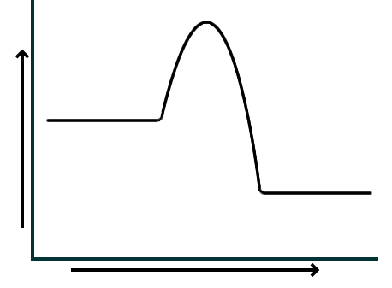

Activation Energy (Ea)

The required energy needed in order for the reaction to occur

Enthalpy: A measure of energy including both potential and kinetic energy.

Reactants

ΔH

Products

Change in Enthalpy/Heat of reaction

Net energy change;

+ve ΔH suggest endothermic reaction

-ve ΔH suggests exothermic reaction

Progress of Reaction

(What happens if it was backwards. What will the changes to Ea, ΔH and the overall shape be?

Ocean Acidification: Increasing H+(aq) in ocean ie decrease of pH.

~Full equations for ocean equilibrium

1. CO2(g) >< CO2(l)

2. CO2(aq) + H2O(l) >< H2CO3(aq)

“Ocean’s buffering system” through Le Chatelier’s Principle

3. H2CO3(aq) >< H+(aq) + HCO3-(aq)

4. HCO3-(aq) >< H+(aq) + CO32-(aq)

~Effects include; coral bleaching, weakening shells (reducing CO32- for CaCO3 shells)

**Acid and bases**

Arrhenius Theory

~Acids will ionize in solution producing H+ ions

~Bases will dissociate in solution releasing OH- ions

~Strong acids and bases ionize/disassociate fully, indicated with a single, forward arrow. Weak acids and bases will only partially ionize/disassociate, indicated by a double forward and reverse arrow

~Limitations: Only applied behaviour in aqueous solutions, only predicts bases with hydroxides e.g. carbonates, oxides and salts are all basic, but are not predicted since they will not release H+ or OH-

Bronsted-Lowry Theory

~An acid will donate a proton ie. H+ donors. When ionised in water (hydrolysis), creates H30+

~A base will accept a proton ie. H+ acceptors. When undergoes hydrolysis, creates OH-

~When reversible, there are “conjugate acids” (from forward base) and “conjugate bases” (from forward acid); showing that both forward and reverse are acid-base reactions. Difference between pairs should be by a H+

Ka/ Acid dissociation constant; numerical value of the extent to which proton transfer reaction goes to completions ie. Acid strength indicator.

~Ka= [forward product] x [forward product] … / [forward reactant] x [forward reactant] …

~Only include species with a concentration ie. Gaseous and aqueous (solids and liquids have constant concentration thus is only “1.”

~If Ka is large, favour forward reaction ie acid is strong and conj. Base is very weak.

~If Ka becomes smaller, more favouritism to reverse reaction ie. Conj. Base becomes a stronger base

Polyprotic acids; acids which are willing to donate 2 or more protons per molecule (H+)

`~The more protons donated, the less acidic it is (less willing to donate a proton) thus the Ka decreases

~e.g. H2SO4(aq) > HSO4-(aq) + H+(aq) >SO42-(aq) + H+(aq)

Acidity of a salt

Acidic Neutral

Basic

|  |  |  |  |
| --- | --- | --- | --- |
| **Cations** | | | |
| Na+ | K+ | Rb+ | Cs+ |
| Mg2+ | Ca2+ | Sr2+ | Ba2+ |
| **Anions** | | | |
| Cl- | Br- | I-, |  |
| ClO4- | BrO4- | ClO3- | NO3- |

|  |  |  |  |
| --- | --- | --- | --- |
| NH4+ | Al3+ | Pb2+ | Sn2+ |
| Transition metal ions | | | |
| HSO4- | H2PO4- |  |  |

|  |  |  |  |
| --- | --- | --- | --- |
| F- | C2H3O2- | NO2- | HCO3- |
| CN- | CO32- | S2- | SO42- |
| HPO42- | PO43- |  |  |

Acidity and pH

~ H20 >< H+ + OH- ΔH=55.8 kJ/mol

~Kw (autoionisation of water) = 1 x 10-14 (at 25°C) meaning [H+][OH-]=1 x 10-14

~ ie. Kw suggests very small tendency for water to ionise, but Kw changes with temperature ie. Higher temp >> higher Kw

~pH = -log([H+]) /// 10-(pH) = [H+]

~Lower pH =more acidic, less basic /// higher pH =more basic, less acidic /// pH= 7 = neutral

Buffers; weak acid/conjugate base or weak base/ conjugate acid pairs which work to resist pH change. Works through Le Chatelier’s principle

~Buffer Capacity; the strength of the buffering power of a buffer ie. Ability to neutralise excess acid or base without an appreciative change in pH.

~High concentration of both acid/base conjugate pairs (so both species do not get depleted or reduced in conc.

~Similar concentrations of acid/base conjugate pairs

Ie. pKa = [forward conjugate pair] / [forward acid/base] ≈ 1

~Ionisation constant; [H+]/[HA]

Titration; Goal; to find the equivalence point, thus finding an unknown solution’s concentration

~Equivalence point; the theoretical point in which neither acid nor base remains ie. Point of neutralisation. Depending on the combo of strength of acid and base, this may happen and varying pH’s

~End point; the practical point in which equivalence point is observed/estimated. Through a suitable pH indicator, the colour of the aliquot will change when a certain pH is reached, thus suggesting end point has been reached. End point is an estimate of the equivalence point

~Aliquot; sample of the acid/base solution

~Titre; solution added to aliquot from the burette

~Acid-Base indicator; a weak acid or base which changes colour based on the acidic/basic form it takes. They can change colour based on pH because they change forms at varying pH’s

~Hind + H20 >< H30+ + Ind- << acidic hydrolysis of indicator (Le Chats anyone?)

~Standard solution; one solution with known concentration

~Primary standards must;

~Have high molar mass

~Stable ie. Not readily react in air

~Found in a pure form which is consistent with chemical formula

~Secondary standards; a solution which concentration is found during the titration ie. Back titrations

~Errors; mistakes made affecting the results of the titration

~Accuracy; how close it is to the true value

~Precision; set of measurements which are in an acceptable range of true value

~Random error; the cause of inconsistent results; e.g. rinsing poorly, careless attention to end point change, poor technique. Cannot be eliminated by can be reduced through repetition ie. Repeating titration

~Systematic error; the cause of consistently lower or consistently higher results; e.g. choosing the wrong indicator. Eliminated by using correct technique.

~Examples of errors

~Clean; firstly with detergent to stop water sticking on glassware

~Final rinse; pipette, burette and storage bottle with reagent to be filled with; Flasks are cleaned with distilled water

~Choosing indicator; Use only a few drops (consistently) Choose with distinct colour change which change comes close to the pH of equivalence point

~ low pH (strong acid, weak base)

>> methyl orange (red <3.1 // yellow >4.4)

~ neutral pH (same strength)

>> bromothymol blue (yellow <6 // blue >7.6)

~ high pH (weak acid, strong base)

>> phenolphthalein (colourless <8.3 // pink >10)

~Reading scales; read at horizonal eye level

~Discharge pipette; allow time for liquid to drain

~End point; drop titre dropwise while swirling. Watch carefully for end point

without overshooting.

~Titration curve; curve how pH in conical flask changes rapidly at equivalence

~Inflection in graph represents equivalence point

~Check where inflection occurs ie. At what pH and compare with colour change of chosen indicator for suitability

~Complete neutralisation≠pH=7

~Neutralisation between strong base + weak acid or vice versa…

**Redox**: A type of reaction where a species gets oxidised and another reduced

~Oxidised; the loss of one or more electrons

~Reduction; the gain of one or more electrons

~Common redox reactions

~Metal-metal ion: Oxidation of metal element, reduction of aqueous metal less reactive to previous metal element ie. Electrons go from metal element to aqueous metal

~Halogen-halide ion displacement: Oxidation of less reactive halide, reduction of a halogen ie. Electrons go from halide ion to halogen

~Combustion (BURNNN!!!!): Oxidation of fuel, reduction of O2(g)

~Corrosion of iron: Oxidation of reactive metal, reduction of O2 (g)

~Oxidation numbers

~How to determine Oxidation numbers

~Free state e.g. Cl2(g) = 0

~Monoatomic have oxidation no. equal to charge e.g. Al3+(aq) = 3

~Hydrogen atoms bonded have +1 e.g. H, in HCl = 1

~Hydrides e.g. H in NaH has -1

~Oxygen atoms bonded have -2 e.g. O, in H2O = -2

~Peroxides ie. O in H2O2, have -1

~If there are a change in oxidation numbers from reactants to products, then it is a redox reaction

~Increase in oxidation number = species being oxidised ie. Reducing agent

~Decrease in oxidation number = species being reduced ie. Oxidising agent

~Confused? Remember “agent” = a trigger for something to happen therefore the “______ agent” is the thing that makes ______ happen

~Half Equations; half equations of a redox reactions

1. Show both the species and the product of half equation
2. Balance element
3. Balance O by adding H2O if needed
4. Balance H by adding H+ if H2O was needed
5. Balance CHARGE by adding e-

Table of Standard Reduction Potentials: Table ranking the strength of oxidising agents (reduced species)

~” Standard”: at SLC, 1 mol. Relative to the reduction by H2 gas (that’s why you have “exactly 0”)

~” Reduction”: Comparing reduction reactions ie. The further up, the more likely to be reduced the further down, the more likely to be oxidised

~” Potentials”: The voltage theoretically created (E0)

~If E0 > 0, reaction will be spontaneous

**Electrochemistry**

Galvanic Cell

**Galvanic/ Electrochemical/ Voltaic cells**

~To create electrical energy by using chemical energy

~This is done through voltages from spontaneous redox equations

Salt bridge: allows ions to pass between oxidising and reducing agents without direct contact

Cations to cathode Anions to anode

Electrons flow from – to +

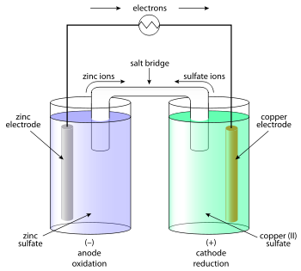

Zinc Cathode will lose mass, since product is Zn2+(aq)

Copper Cathode will gain mass, since product is Cu(s)

OILRIG, AN OX//RED CAT?

Electrolytic Cell

External power supply provides energy for a normally non-spontaneous redox to occur

Inert (non-reactive) electrodes; do not get involved in the chemical reaction. When voltage is added, the electrodes become oppositely charged

**Electrolytic/ Electrolysis cell**

~To create chemical change by using electrical energy

~This is done by using an external electrical power supply to power what would’ve been a non-spontaneous reaction

Same; remember- oxidation is loss of electrons, reduction is the gain of electrons (AN OX and RED CAT still apply)

~Cations to Anode, Anions to Cathode

~Electrons from + to –

~Electrolytic: “don’t PANIC”

(Positive Anode Negative in Cathode)

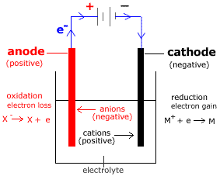

Electrolyte: solution that readily disassociates. Provides the ions which them move to respective electrodes

~Possible to get reactive electrodes or aqueous salts

~Reactive electrodes e.g. Cu(s) electrodes will have one electrode lose mass (anode) and the other gain mass (cathode)

~If water is oxidised, O2(g) forms at anode, what happens to pH?

2H2O(l) >> O2(g) + 4H+ (aq) + 4e-

~If water is reduced, H2(g) forms at cathode, what happens to pH?

2H2O(l) + 2e- >> H2(g) +2OH-(aq)

Types of Galvanic cells

~Primary cell; non-rechargeable cells (single use) because amount of oxidant and reductant is fixed thus cannot be added to “recharge”. Examples include; dry cell, alkaline cells, silver oxide button cell, lithium cell.

~Secondary cell; rechargeable cells (multi use). Recharged by adding a voltage (electrolysis) to reverse the spontaneous, discharge reaction, to regenerate original oxidant and reductant by reversing anode and cathode half reactions.

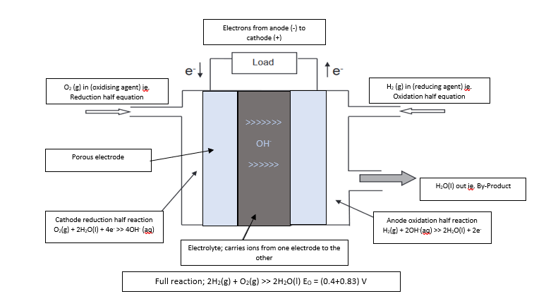~Fuel cells; not primary or secondary. Generates electricity through the constant addition of oxidising and reducing agents ie. Does not store contents.

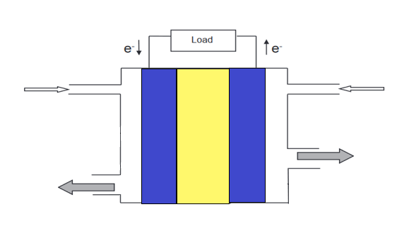

H2(g) in

O2(g) in

>>>>>>

H+

>>>>>>

Depleted fuel and gases out

Remaining O2(g), heat, H2O(l) out

Electrorefining and Electroplating

~Electrorefining: To remove impurities from blister (impure) copper through electrolysis

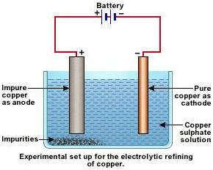

Pure Copper as cathode; gains mass from copper from blister cathode. Only gains copper because lower reduction potential of impurities.

“Anode Slime”: Less reactive metals ie. More likely to reduce, do not dissolve due to lower oxidation potentials

Impure Copper as anode; will lose mass ie. impurities become part of “anode slime. Copper will oxidise and solidify at cathode.

C

Electrolyte made up of based on cation ie. Copper coating ie. Copper Sulfate

Impurities which are more likely to oxidise will also oxidise from blister copper but, will not form solid at pure copper.

~Electroplating: To add a thin coating of a metal onto another metal

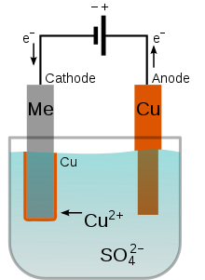

Cathode: Metal to be coated

Why? Because CATHODE GAINS MASS (from anode)

Anode: Metal to make up the coating

Why? Because ANODE LOSES MASS (to go to cathode)

Electrolyte made up of based on cation ie. Copper coating ie. Copper Sulfate

**Organic Chemistry**

~Alkanes; straight chains with single bonds

~Strongest intermolecular force is dispersion force ie. Small amount of energy required to break intermolecular bonds

~Undergo substitution (CH4 +Cl2 >> CH3Cl + HCl) ie. Replacing a H with a halogen and form another small molecule

~Combustion

~Alkenes; straight chains with double bonds

~Strongest intermolecular force is dispersion force ie. Small amount of energy required to break intermolecular bonds

~Undergo Addition reaction (CH­2CH2 + Br2 >> (Br)CH2CH2(Br) ie. Breaking the double bond

~Combustion

~Hydration e.g. CH2CH2 +H2O >> CH3CH2OH ie. Making an alcohol

~Markovnikov’s rule; H goes to the C with most H’s, other goes to the C with less H’s

~Alcohols; Has an -OH group (hydroxyl group), named with a “-ol”

~Strongest intermolecular force is hydrogen bonds ie. Large amounts of energy required to break intermolecular bonds

~Primary alcohols (C connected to OH has only another C connected to it) oxidise to aldehydes (incomplete) and then to carboxylic acids (complete)

~Secondary alcohols (C connected to OH is connected to two other C’s) oxidise to ketones

~Tertiary alcohols (C connected to OH is connected to three other C’s) do not oxidise

~Aldehydes; Has an -CHO group; named with a “-al”

~Strongest intermolecular force is dipole-dipole ie. Moderate amounts of energy required to break intermolecular bonds

~Ketones; Has a -C=O (carbonyl) group; named with a “one”

~Strongest intermolecular force is dipole-dipole ie. Moderate amounts of energy required to break intermolecular bonds

~Carboxylic acid; Has a -COOH (carboxyl group = carbonyl + hydroxyl); named with -oic acid

~Strongest intermolecular force is hydrogen bonds ie. Large amounts of energy required to break intermolecular bonds. Also has the double bond O suggesting more energy is required to break intermolecular bonds compared to alcohol, even though both exhibit H-bonding (strongest intermolecular force)

~This and alcohol needed for esterification

~Weak acids which can also undergo hydrolysis

~CH3COOH(aq) + H2O(l) >< CH3CHOO-(aq) + H3O+ (aq) Ka=1.75 x 10-5

~Amine; has a -NH­2 (amine or amino) group; named with -amine

~ Strongest intermolecular force is dipole-dipole ie. Moderate amounts of energy required to break intermolecular bonds

~Amides; has a -CONH2 group (carbonyl + amine); named with -amide

~ Strongest intermolecular force is dipole-dipole ie. Moderate amounts of energy required to break intermolecular bonds. Also has the double bond O suggesting more energy required to break amide intermolecular compared to amine intermolecular.

~Esters; product of the reaction between an alcohol and carboxylic acid in acidic condition

~R1-COOH + HO-CH2-R2 >< R1-COO-CH2-R2

~Generally have a fruity smell

~Can undergo hydrolysis

~In acidic conditions, creates carboxylic acid and alcohol (ie. The reactants)

~In basic conditions, creates carboxylate salt and alcohol (don’t forget the signage of the salt!)

~Physical properties of organic compounds

~Solubility in water; how well it dissolves in water (polar solution)

~Shorter chains, polarity within molecule and stronger intermolecular forces result in high solubility

~Boiling point/melting point; how much energy is needed to break bonds

` ~Longer chains, polarity within molecule and stronger intermolecular forces result in higher BP/MP

Saponification: Making a soap from animal fat or vegetable oil.

CH2-O-C(O)-(CH2)16-CH3 *3 +3NaOH > CH2-OH *3 + 3Na-O-C(O)-(CH2)16 CH3

(Ester + strong base >> Soap with Carboxylic bit + Alcohol)

Detergents are (R-Benzene ring-(2

9 8O-Na+) where R= aliphatic chain with +10 carbons

Cleaning action; Hydrophobic tail dissolve in grease (dispersion) and hydrophilic head is intermolecularly bonded to the water (dipole/hydrogen bonding). Through agitation, dirt is lifted off fabric using the cleaning agent as a medium.

Hard water: Water with high conc. of Ca2+ and/or Mg2+ ions.

Soaps don’t work in hard water because they form insoluble substances with Ca2+ and Mg2+. Detergents work in hard water and you need less detergent to clean the same stain as soap but detergents come from synthetic material e.g. H2SO4 and petroleum products.

Macromolecules: extremely large molecules like synthetic mers (e.g. polypeptides, proteins like DNA, RNA and polysaccharides like cotton).

Polymers/Plastics/Synthetics:

~Can be made into fibres for fabric e.g. nylon, polyester, polypropene, Teflon, Kevlar

~Thermoplastics: soften when heated, therefore can be melted and reshaped e.g. PET, HDPE, PVC

~Thermosetting: char or decompose to original monomer when heated ie. Cannot be reshaped by heating

Polymerisation: Joining monomers together to create a polymer

~Cross linking: chains joined to other chains.

~Addition Polymerisation: saturation of double bond through polymerization.

~Condensation Polymerisation: Polymerisation which results in the loss of small molecules ie. H20 or CO2

Polypeptides: Natural polymers formed by the combination of alpha amino acids.

~Alpha amino acids; NH2 group is connected to the same C which is connected to the COOH group ie.

R-CH­2(NH2)-COOH where R is the rest of the chain

~Zwitterions; an ion with a positive and negative charge but is a neutrally charged ion overall.

~Created by removing a H where possible (generally from COOH groups) and adding it wherever possible (generally to a NH2 group)

Protein: 50+ chain of alpha amino acids ie. Long polypeptide.

~Primary structure: linear sequence of peptide chain

~ Primary structure sequence starts at N-Terminus (The NH2 end) while the primary structure sequence finishes at the C-Terminus (COOH end). Therefore, all proteins have NH2 and COOH

~Secondary structure: regular arrangement of the sections of the protein chain.

-Alpha Helix: A coiled ribbon formed through the H-bonds between the protein backbone and N-H / C=O bonds. N is 4 residues away from each other.

-Beta Pleated Sheets: Flat sheets held together by the H-bonds between different parts of the one polypeptide chain or between different polypeptide chains.

~Tertiary Structure: Overall 3D shape caused by ionic and disulfide bridges, dispersion force and H-bonds to adjacent chains. Disulfides are strong due to oxidation; stronger than H-bonds. Ionic bonds are very strong.

Enzymes: Proteins with a specific shape and complex structure which act as catalyst for specific reactions (enzyme specificity)

~Lock and Key model: How Enzymes catalyse reactions which break apart the substrate molecule.

1. Substrate approaches enzymes active site
2. Intermolecular forces hold substrate down. Substrate begins to change through the breaking and forming of new bonds; ie. New substances are being created
3. Changed substrate releases from active site as substrate is not being held by intermolecular forces anymore.

~Benefits of using enzymes;

-less chance of side reactions and creation of unwanted by products

~speeds up reactions for economical production which usually would need high temp/pressure for the same rate

~Disadvantages of using enzymes

-needs to work under specific temperature and pH conditions.

-increasing concentration of substrate does not increase reaction rate (must wait for the previous substrate to finish catalysing first.

Chemical Synthesis: “Creating chemicals”

Goal: maximise yield and rate of production

Green Chemistry: Clean Chemistry

1. Prevent chemical waste is better than treating it
2. Incorporate all materials in the process
3. Reduce hazards
4. Minimize toxicity of chemicals
5. Use safe chemicals whenever can
6. Be energy efficient
7. Use renewable, raw materials when can
8. Use less derivative reactions
9. Use catalysts because they’re better than reagents
10. Design for self-degrading products that will not stay in environment for too long
11. Analyse in real time
12. Accident prevention is good

Factors resulting in a reduced yield of products

Loss of reagent due to side reactions

Physical loss of products ie. Cannot fully separate products

Incomplete equilibrium reactions

Presence of impurities in reagents ie. Reagent added is not the same as amount measured

Why do we use catalysts?

~Increase rate of formation of products

~Better yield at lower temperatures therefore catalysts make rate viable

~Some are reusable ie. Cost effective

~Lowers operating temperature and pressure

~Saving fuel

~Making it safer

~Reducing thermal pollution

Biofuels: Creating fuel from biomass

Advantages

Biofuels are renewable resource while fossil fuels aren’t

Biofuels have limited to no health consequences

Balances out in the carbon cycle (photosynthesis just creating mass again)

Petroleum fuels create SO2 which is dangerous for people inhaling

Biofuels burn cleaner

Not much energy needed to create fuel

Disadvantages

More workers are needed

Slow process

Needs to distill to be made pure

Ethanol creation through Fermentation

Hydrolysis: from sucrose to glucose/fructose

Fermentation: from glucose/fructose to ethanol

Ie. C6H12O6 + H2O >> 2C2H5OH + 2CO2

Fractional distillation: To obtain pure ethanol

Ethanol creation through synthesis of ethene

Hydrolysis with steam: From ethene to ethanol ΔH = -45kJ/mol

Fractional distillation: To obtain pure ethanol

Biodiesel: Methyl or Ethyl esters created by the (strong) base catalysed trans-esterification of triglycerides.

1. Remove water- don’t want triglyceride turning into soap
2. FFA (Free fatty acid) content below 4%
3. Treat with methanol or ethanol to create ester
4. Washed and dried

Petroleum biodiesel looks like; H3C-(CH2)14-CH3

Biodiesel will look like; H3C-O-C(O)-(CH2)13-CH3

Advantages of using lipase (enzyme) as a catalyst instead of NaOH or KOH

Milder pH and temperature range

Simultaneously catalyse transesterification of TG and esterification of FFA into biodiesel

Less energy needed in the whole reaction

Simplify purification process and reduce environmental problem

No side reactions if done correctly

Disadvantages of using lipase as a catalyst

Slower acting than strong base

Expensive compared to strong base

Hard to recover lipase after it’s used as a catalyst

Haber process: create NH3

N2 (g)+ 3H2 (g)> 2NH3 (g) ΔH=-92 kJ/mol

Compressor: maintains 15000-35000 kPa. Forces particles to enter converter

Convertor: maintains 350-550°C. Converts the N2(g) and H2 (g) into NH3 (g)

Condenser: Cools the NH3 gas into liquid form to separate from the N2 and H2. NH3 gets stored while remaining H2 and N2 go back into the convertor.

Contact process: create H2SO4

1. S(l) + O2(g) > SO2(g) ΔH=-297kJ/mol

Molten sulfur is burnt ion dry air around 1000°C

1. 2SO2(g) + O2 (g) <> 2SO3(g) ΔH = -198 kJ/mol

Sulfur dioxide is converted to sulfur trioxide

* 1. SO3 (g) + H2SO4(l) >H2S2O7(l)
  2. H2S2O7(l) + H2O(l) > 2H2SO4(l)
  3. SO3(g) + H2O (l) > H2SO4

Going through the creation of Oleum (3a) adding water to Oleum (3b) creates H2SO4.

3c is the full equation

(If it is just H2O + SO3, we would only get mist particles of H2SO4.

Manufacture of ethyl ethanoate

Ester reaction of CH3CH2OH and CH3COOH

Can you go from CH2CH2 to CH3COOCH2CH3?

Uses extra of the CH3CH2OH because CH3COOH is more expensive

Maximise the yield of CH3COOCH2CH3 and consume as much CH3COOH as possible

Different types of addition polymers

Polyethene ie…. CH2CH2…

LDPE (Low density polyethene): soft, flexible and insulating. Good for packaging film, tubing, bottles and toys

HDPE: (High density polyethene): Tougher and more rigid. Good for chopping boards, water pipes, toys, buckets and crates

Polypropene ie. …CH2(CH3)-CH2…

Low density polymer. Good for rope and carpet. Good to mould toys, chairs and furnitures, car bumpers or dashboards

Polychloroethene ie. …CH2(Cl)-CH2…

Also called Vinyl chloride/Poly vinyl chloride ie. Monomer/polymer. Normally hard and brittle. Good for construction products e.g. window frames, pipes and gutters.

Polytetrafluoroethene ie. …(F)(F)C-C(F)(F)…

Chemically stable, non stick, low friction, oil and water repellent. Good for non-stick coatings for low friction surfaces, semi-permeable membrane in fuel cells.

Phenylethene ie, …(Benzene ring)C-C…

Also known as polystyrene. Hard and brittle. Used to make petri dishes, toys and casings. Can also be made in “low density” expanded solid. Good for insulation, foam cups and packaging foam.

Different types of condensation polymers

Nylon (n1, n2) where n1 represents no. carbon in the diamine and n2 represents no. carbon in the dicarboxylic.

The world’s first synthetic fibre: durable, wear and abrasion resistant, good ability to stretch. Good for making fibres for clothing, rope, fishing line, as well as skate wheels, hoses and bearings.